Exercise 2: E-commerce Platform Search Function
Scenario:
You are working on the search functionality of an e-commerce platform. The search needs to be optimized for fast performance.
Steps:
- Understand Asymptotic Notation:
  - Explain Big O notation and how it helps in analyzing algorithms.
  - Describe the best, average, and worst-case scenarios for search operations.
- Setup:
  - Create a class Product with attributes for searching, such as productId, productName, and category.
- Implementation:
  - Implement linear search and binary search algorithms.
  - Store products in an array for linear search and a sorted array for binary search.
- Analysis:
  - Compare the time complexity of linear and binary search algorithms.
  - Discuss which algorithm is more suitable for your platform and why.
Code:

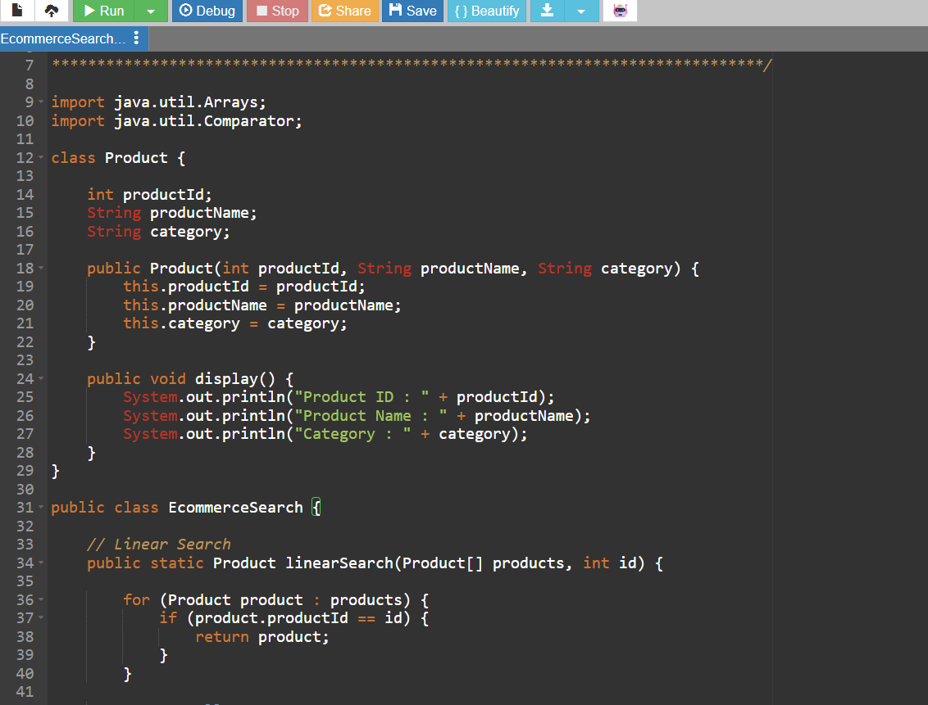

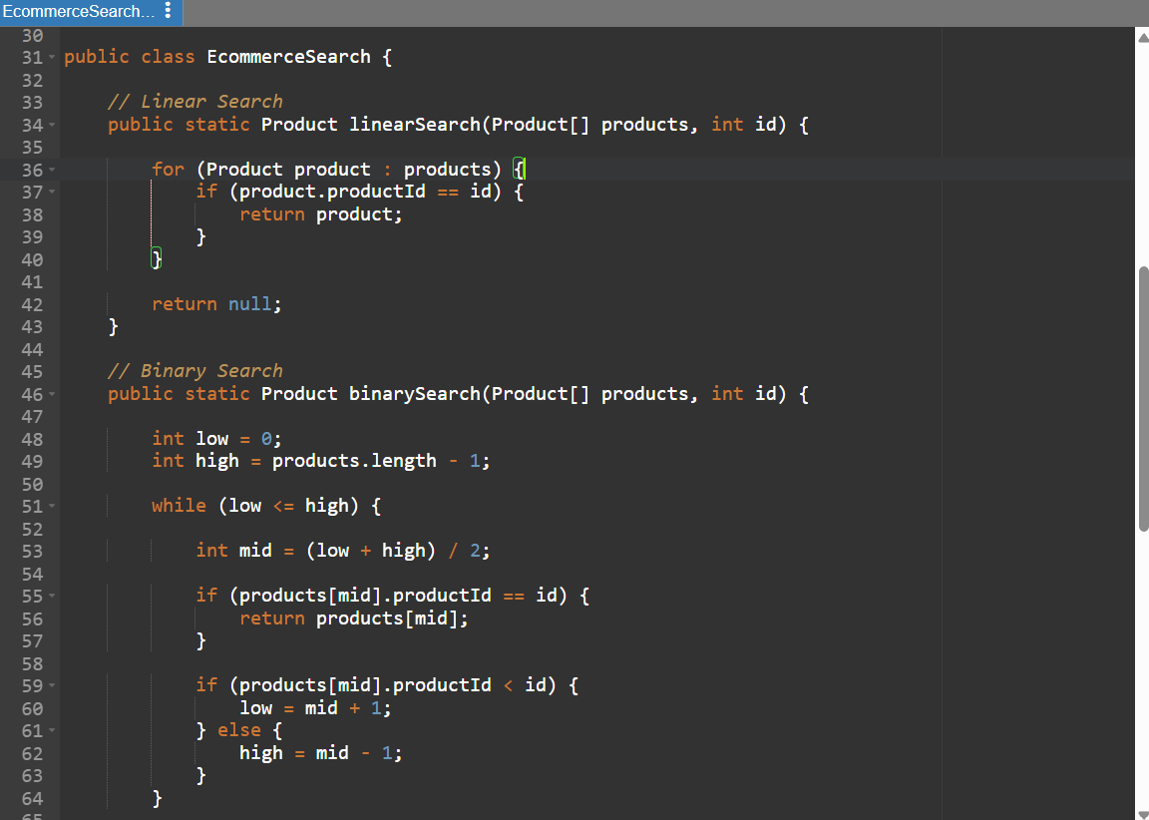

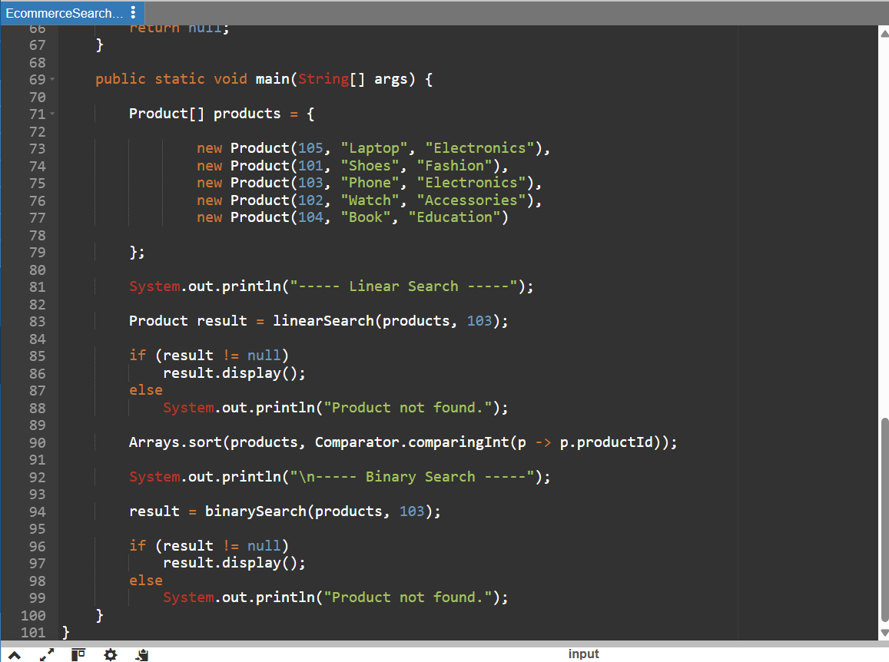

Output:

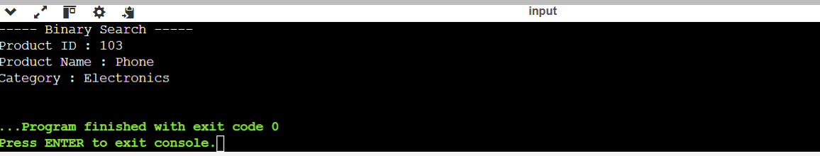
Exercise 7: Financial Forecasting
Scenario:
You are developing a financial forecasting tool that predicts future values based on past data.
Steps:
- Understand Recursive Algorithms:
  - Explain the concept of recursion and how it can simplify certain problems.
- Setup:
  - Create a method to calculate the future value using a recursive approach.
- Implementation:
  - Implement a recursive algorithm to predict future values based on past growth rates.
- Analysis:
  - Discuss the time complexity of your recursive algorithm.
  - Explain how to optimize the recursive solution to avoid excessive computation.

Code:
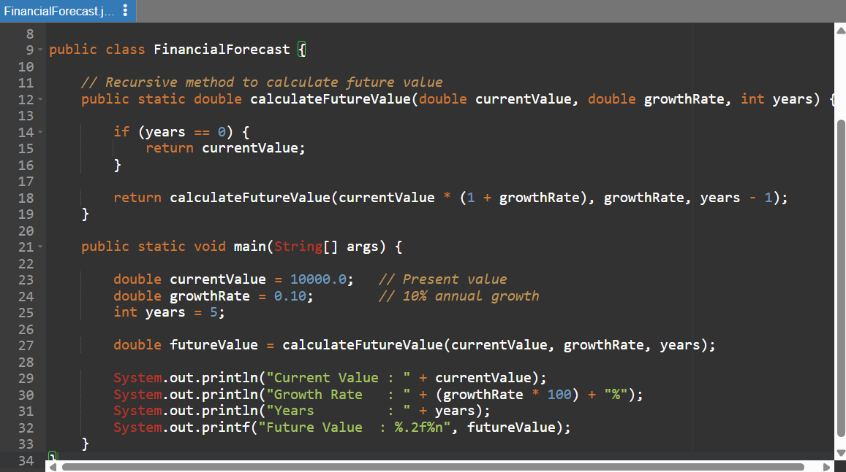

Output:

